ITCS 1212L

Lab lessons 3

Rational and equality operators, logical operators, conditional operators, Conditional structures, Selective structures, Type casting, working with debuggers

Rational and equality operators: ( ==, !=, >, <, >=, <= )

In order to evaluate a comparison between two expressions we can use the relational and equality operators. The result of a relational operation is a Boolean value that can only be true or false, according to its Boolean result. We may want to compare two expressions, for example, to know if they are equal or if one is greater than the other is. Here is a list of the relational and equality operators that can be used in C++:
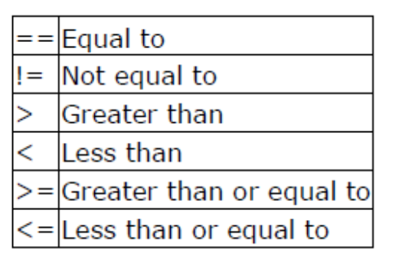
Here there are some examples:

(7 == 5) // evaluates to false.
(5 > 4) // evaluates to true.
(3 != 2) // evaluates to true.
(6 >= 6) // evaluates to true.
(5 < 5) // evaluates to false.

Of course, instead of using only numeric constants, we can use any valid expression, including variables. Suppose that a=2, b=3 and c=6,

(a == 5) // evaluates to false since a is not equal to 5.
(a * b >= c) // evaluates to true since (2*3 >= 6) is true.
(b + 4 > a * c) // evaluates to false since (3+4 > 2*6) is false.
((b = 2) == a) // evaluates to true.

Be careful! The operator = (one equal sign) is not the same as the operator == (two equal signs), the first one is an assignment operator (assigns the value at its right to the variable at its left) and the other one (==) is the equality operator that compares whether both expressions in the two sides of it are equal to each other.
Thus, in the last expression ((b = 2) == a), we first assigned the value 2 to b and then we compared it to a, that also stores the value 2, so the result of the operation is true.

Logical operators ( !, &&, || )

The Operator ! is the C++ operator to perform the Boolean operation NOT, it has only one operand, located at its
right, and the only thing that it does is to inverse the value of it, producing false if its operand is true and true if its
operand is false. Basically, it returns the opposite Boolean value of evaluating its operand. For example:

!(5 == 5) // evaluates to false because the expression at its right (5 == 5) is true.
!(6 <= 4) // evaluates to true because (6 <= 4) would be false.
!true // evaluates to false
!false // evaluates to true.

The logical operators && and || are used when evaluating two expressions to obtain a single relational result. The
operator && corresponds with Boolean logical operation AND. This operation results true if both its two operands
are true, and false otherwise. The following panel shows the result of operator && evaluating the expression a &&
b:

&& OPERATOR
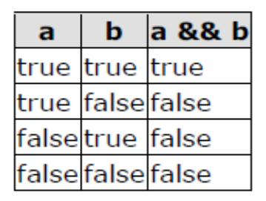
The operator || corresponds with Boolean logical operation OR. This operation results true if either one of its two
operands is true, thus being false only when both operands are false themselves. Here are the possible results of a
|| b:

|| OPERATOR
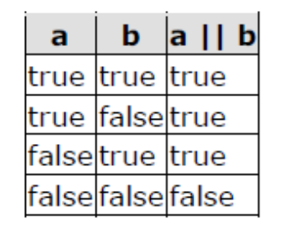
For example:

( (5 == 5) && (3 > 6) ) // evaluates to false ( true && false ).
( (5 == 5) || (3 > 6) ) // evaluates to true ( true || false ).

Or

!(x > z) is equivalent to x <= z

Conditional operator ( ? )
The conditional operator evaluates an expression returning a value if that expression is true and a different one if the expression is evaluated as false. Its format is:

condition ? result1 : result2

If condition is true the expression will return result1, if it is not it will return result2.

7 == 5 ? 4 : 3 // returns 3, since 7 is not equal to 5.
7 == 5+2 ? 4 : 3 // returns 4, since 7 is equal to 5+2.
5 > 3 ? a : b // returns the value of a, since 5 is greater than 3.
A > b ? a : b // returns whichever is greater, a or b.

// conditional operator
#include <iostream>
using namespace std;

int main ()
{
int a,b,c;

a = 2;

b = 7;

c = (a > b) ? a : b;

cout << c;

return 0;

}

In this example a was 2 and b was 7, so the expression being evaluated (a>b) was not true, thus the first value specified after the question mark was discarded in favor of the second value (the one after the colon) which was b, with a value of 7.

Conditional structure: if and else
The if keyword is used to execute a statement or block only if a condition is fulfilled. Its form is:

if (condition) statement

Where condition is the expression that is being evaluated. If this condition is true, statement is executed. If it is false, statement is ignored (not executed) and the program continues right after this conditional structure. For example, the following code fragment prints x is 100 only if the value stored in the x variable is indeed 100:

if (x == 100)
cout << "x is 100";

If we want more than a single statement to be executed in case that the condition is true we can specify a block using braces { }:
if (x == 100)
{
cout << "x is ";
cout << x;
}

We can additionally specify what we want to happen if the condition is not fulfilled by using the keyword else. Its form used in conjunction with if is:

if (condition) statement1 else statement2

For example:

if (x == 100)
cout << "x is 100";
else
cout << "x is not 100";

prints on the screen x is 100 if indeed x has a value of 100, but if it is not -and only if not- it prints out x is
not 100.

The if + else structures can be concatenated with the intention of verifying a range of values. The following
example shows its use telling if the value currently stored in x is positive, negative or none of them (i.e. zero):

if (x > 0)
cout << "x is positive";
else if (x < 0)
cout << "x is negative";
else
cout << "x is 0";

Remember that: in case that we want more than a single statement to be executed, we must group them in a block by enclosing them in braces { }.

The selective structure: switch
The syntax of the switch statement is a bit peculiar. Its objective is to check several possible constant values for an expression. Something similar to the concatenation of several if and else if instructions. Its form is the following:

switch (expression)
{
case constant1:
group of statements 1;
break;

case constant2:
group of statements 2;
break;
.
.
.
default: (is Optional)
default group of statements
}

It works in the following way:

switch evaluates expression and checks if it is equivalent to constant1, if it is, it executes group of statements 1 until it finds the break statement. When it finds this break statement the program jumps to the end of the switch selective structure.

If expression was not equal to constant1 it will be checked against constant2. If it is equal to this, it will execute group of statements 2 until a break keyword is found, and then will jump to the end of the switch selective structure.

Finally, if the value of expression did not match any of the previously specified constants (you can include as many case labels as values you want to check), the program will execute the statements included after the default: label, if it exists (since it is optional). Both of the following code fragments have the same behavior:

Switch example | If-else equivalent
switch (x) {  case 1:  cout << "x is 1";  break;  case 2:  cout << "x is 2";  break;  default:  cout << "value of x unknown";  } | if (x == 1) {  cout << "x is 1";  }  else if (x == 2) {  cout << "x is 2";  }  else {  cout << "value of x unknown";  }

Important note! The switch statement is a bit peculiar within the C++ language because it uses labels instead of blocks. This forces us to put break statements after the group of statements that we want to be executed for a specific condition. Otherwise the remainder statements -including those corresponding to other labels- will also be executed until the end of the switch selective block or a break statement is reached.

For example, if we did not include a break statement after the first group for case one, the program will not
automatically jump to the end of the switch selective block and it would continue executing the rest of statements until it reaches either a break instruction or the end of the switch selective block. This makes unnecessary to include braces { } surrounding the statements for each of the cases, and it can also be useful to execute the same block of instructions for different possible values for the expression being evaluated. For example:

switch (x) {
case 1:
case 2:
case 3:
cout << "x is 1, 2 or 3";
break;
default:
cout << "x is not 1, 2 nor 3";
}

Notice that switch can only be used to compare an expression against constants. Therefore we cannot put variables as labels (for example case n: where n is a variable) or ranges (case (1..3):) because they are not valid C++ constants. If you need to check ranges or values that are not constants, use a concatenation of if and else if statements.

Type Casting:
Converting an expression of a given type into another type is known as type-casting. We have several ways to type cast. The one we discuss in this Lab lesson is implicit conversion.

Implicit conversion: Implicit conversions do not require any operator. They are automatically performed when a value is copied to a compatible type. For example:

short a = 2000;
int b;
b = a;

Here, the value of a has been promoted from short to int and we have not had to specify any type-casting
operator. This is known as a standard conversion. Standard conversions affect fundamental data types, and allow conversions such as the conversions between numerical types (short to int, int to float, double to int...), to or from bool, and some other conversions. Some of these conversions may imply a loss of precision, which the compiler can signal with a warning. (This can be avoided with an explicit conversion, which is not in the scope of this lab lesson)

Debuggers

A debugger is a computer program that assists in the detection and correction of errors in computer programs. In other words, it helps you find logic errors in your code.

This is what the debugging toolbar looks like in codeblocks.

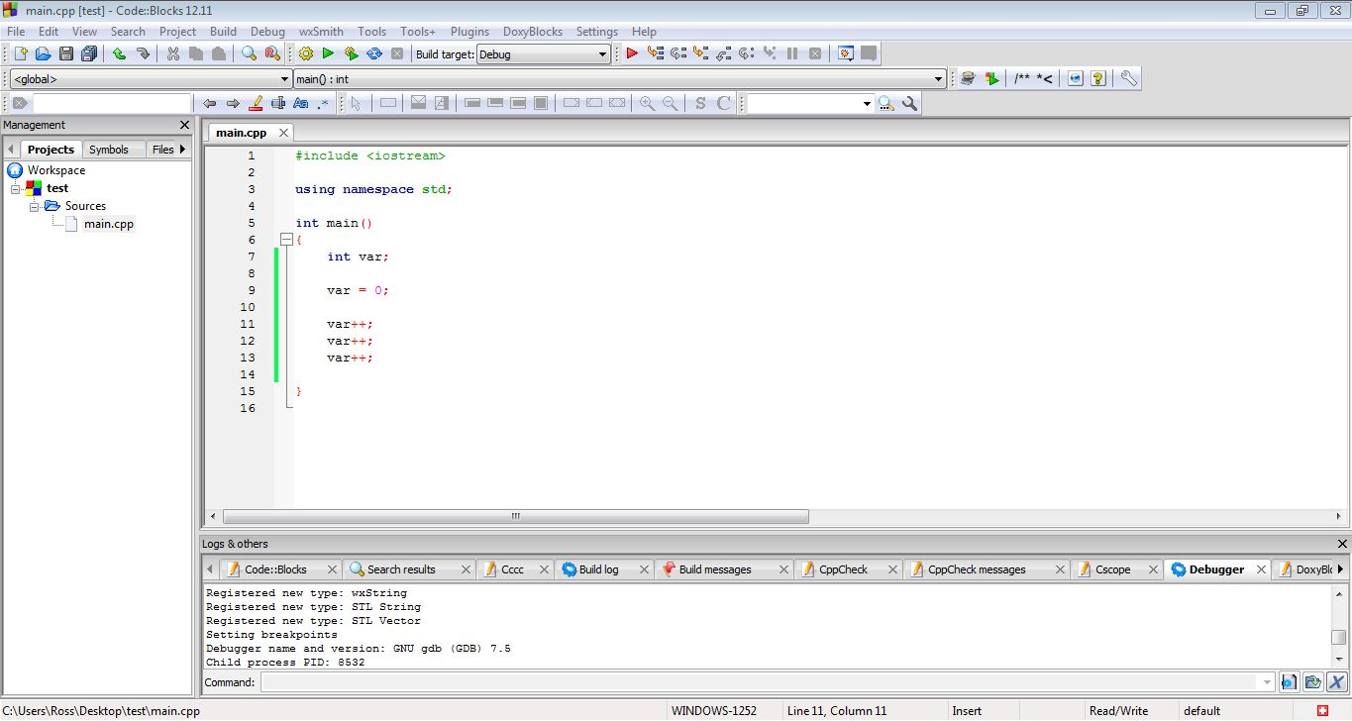
It's located in the top-middle of the screen, above your text editor.

The debugger lets you stop and start your program at any point during its run, and check the status of variables. For example, you can get the program to stop on line 12, so you can check out the value of the variable “var”.

One way to do this is by using the Run to Cursor button. This button will run the program, starting from the beginning and ending wherever your cursor is in the text editor. If you wanted the program to stop on line 12, then you click on line 12 to place your cursor, and then click the Run to Cursor button in the toolbar.

Play around with this and the other buttons before you come to lab. If you get stuck on a hard assignment, you can try to run through the code with the debugger to find any variables that don't have the values you thought they should.

